1. Description of data acquisition in KNA campus

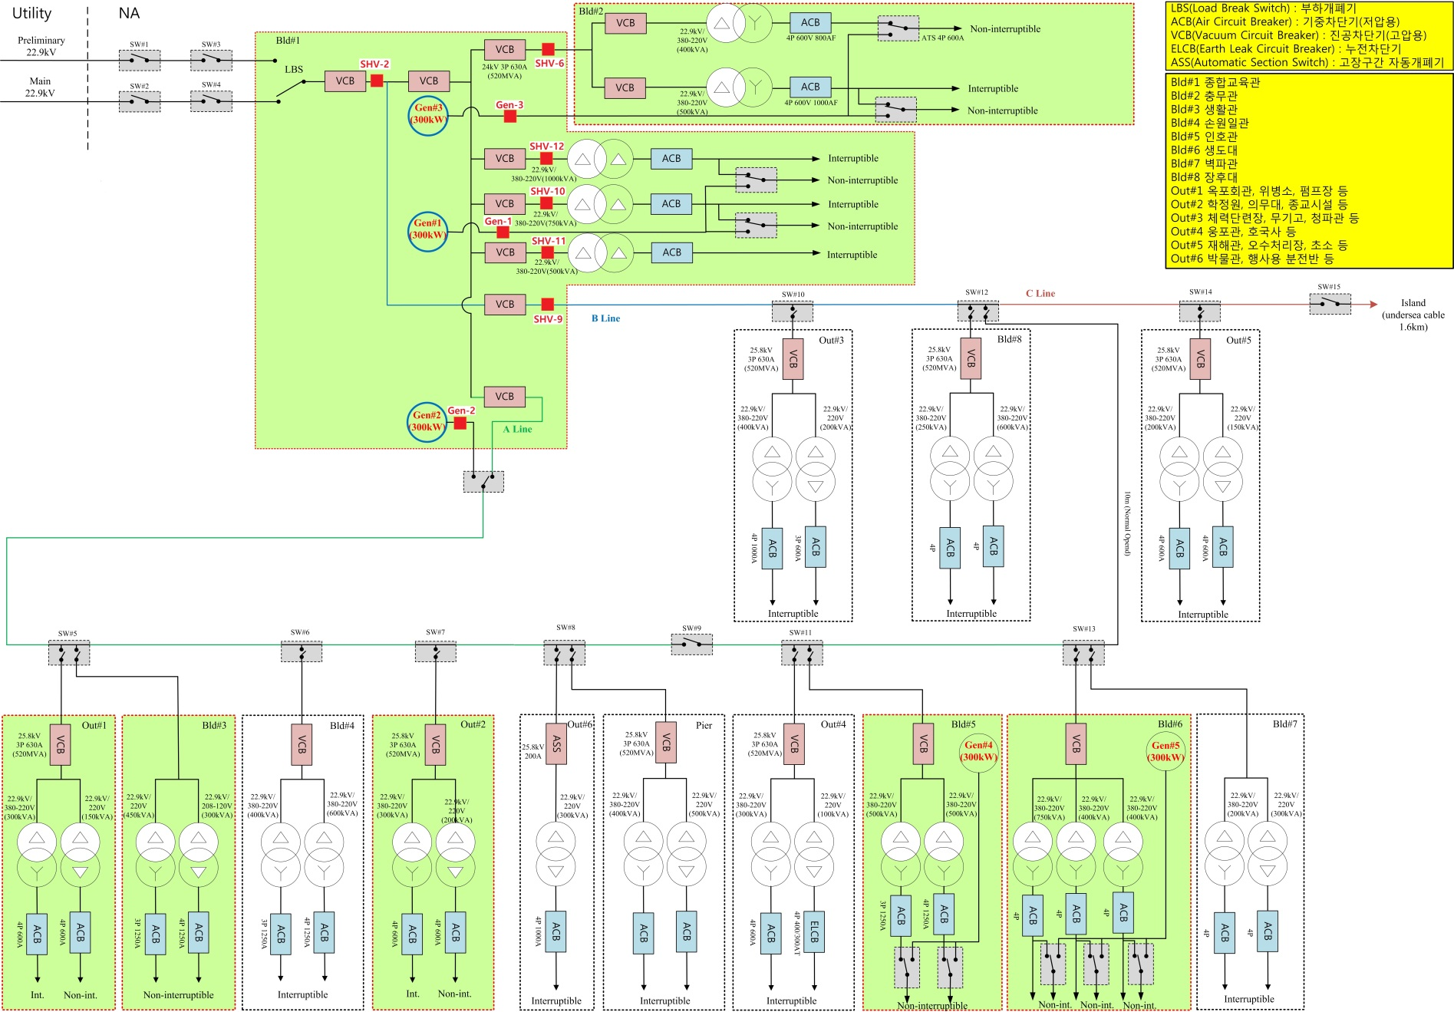

* The power meters to measure power consumption in KNA campus are SHV-2, SHV-6, SHV-9, SHV-10, SHV-11 and SHV-12
* SHV-2 measures the power consumption of whole KNA campus and a small island in the front sea which is not belong to KNA
* SHV-6 measures building #2
* Summation of the measured data of SHV-10, SHV-11 and SHV-12 produces the power consumption of building #1
* SHV-9 measures the power consumption by Out#3, Building #8, Out #5 and an island
* The power provided to A-line are calculated by SHV-2 - (SHV-9 + SHV-10 + SHV-11 + SHV-12), but the power provided to Out #1, Building #3, Out #2, Pier, Building #5 and Building #6 of A-line are not measured separately, which are critical loads.

1. Data files(: MB.zip)
2. The data files, “MB_Power_xxxx” of “MB.zip”, are measured data every 10 second from June. 2016 to May. 2017

* Unit of Y axis is kW
* The first column of MB_Power_xxxx, KNA all, is calculated by SHV-2 – SHV-9. Since SHV-9 measures the power consumption by Out#3, Building #8, Out #5 and an island, the first column does not show the power consumption of whole KNA campus exactly, which is a little bit less.
* The second column of MB_Power_xxxx, BLDG1, is calculated by SHV-10 + SHV-11 + SHV-12
* The third column of MB_Power_xxxx, BLDG2, is the measured data by SHV-6
* The fourth column of MB_Power_xxxx, A line, is calculated by SHV-2 - (SHV-9 + SHV-10 + SHV-11 + SHV-12)

1. The data files, MB_Eng_xxxx are calculated using MB_Power_xxxx, whose Y axis unit is kWh
2. Figures
3. The first column of MB_Power_xxxx

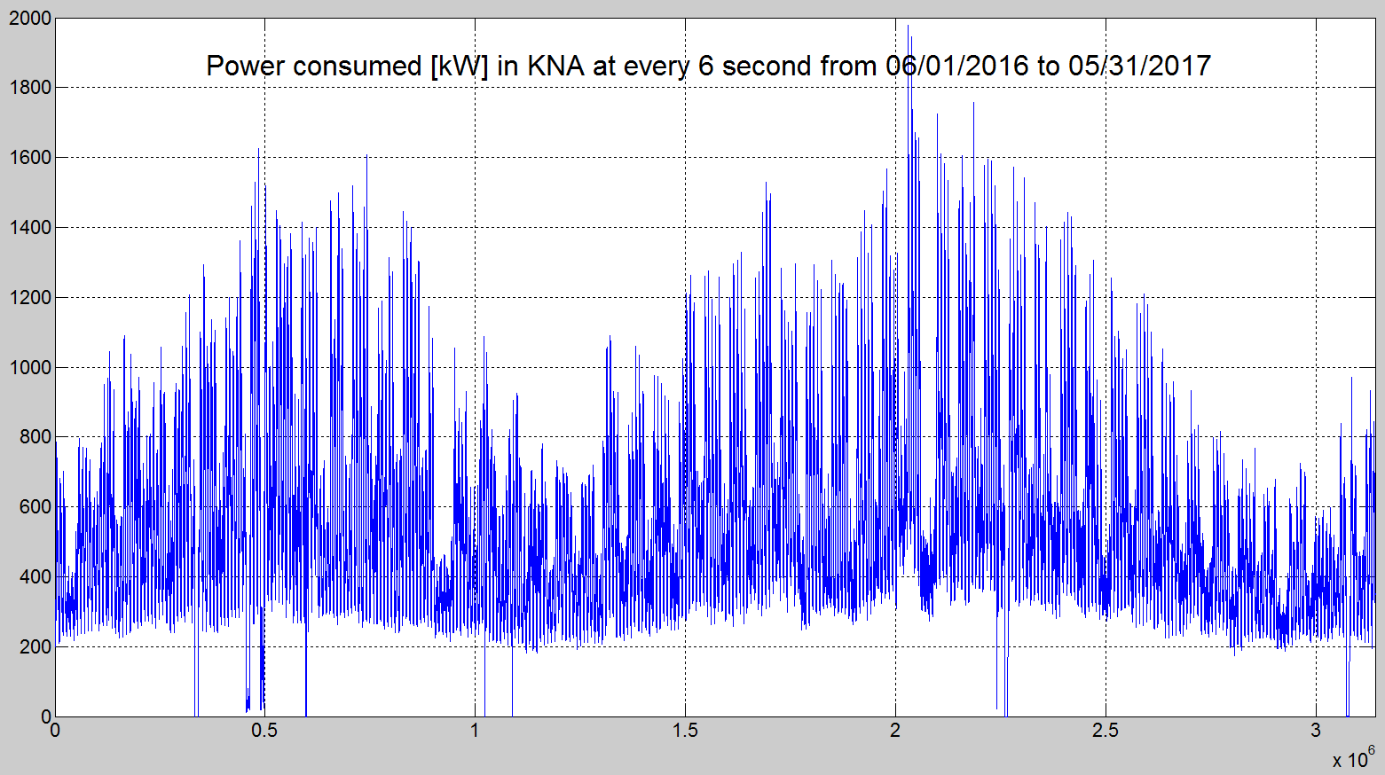

* Unit of X axis is X x 10sec (6 second on the figure is error). The last number of X axis is 3141037 which means about 1 year because (3141037 x 10sec)/3600/24=364 days
* Unit of Y axis is kW

1. The first column of MB_Eng_xxxx

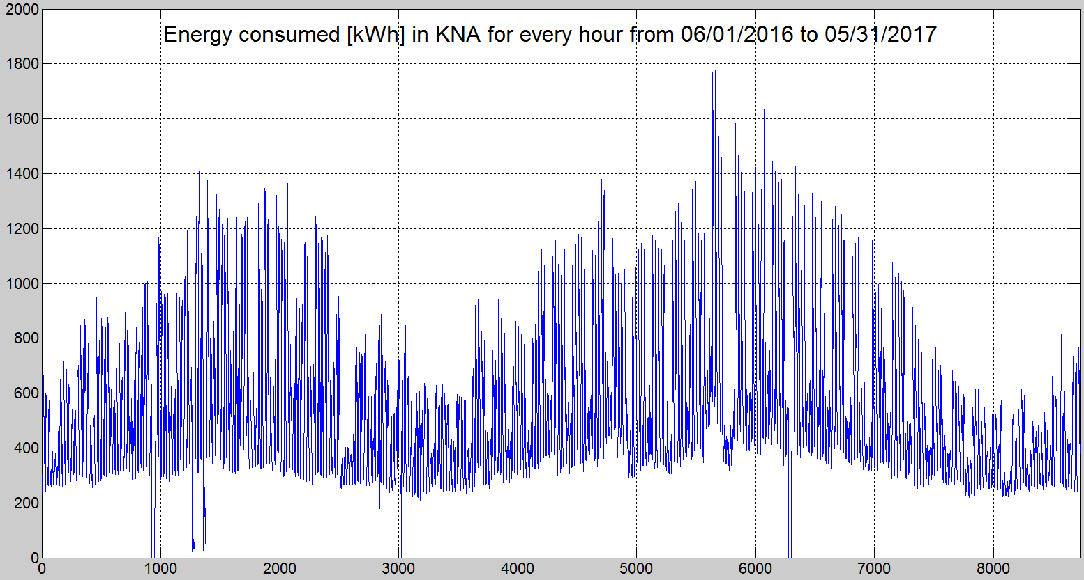

* Unit of X axis is hour. The last number of X axis is 8725 which means about 1 year data because 8725/24=364 days
* Unit of Y axis is kWh

1. The second column of MB_Power_xxxx

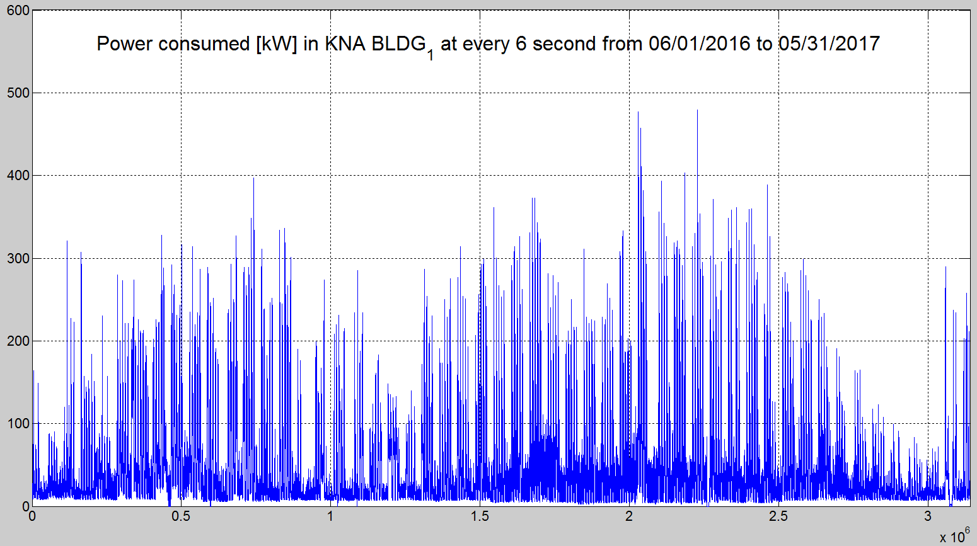

* Unit of X axis is X x 10sec
* Unit of Y axis is kW

1. The second column of MB_Eng_xxxx

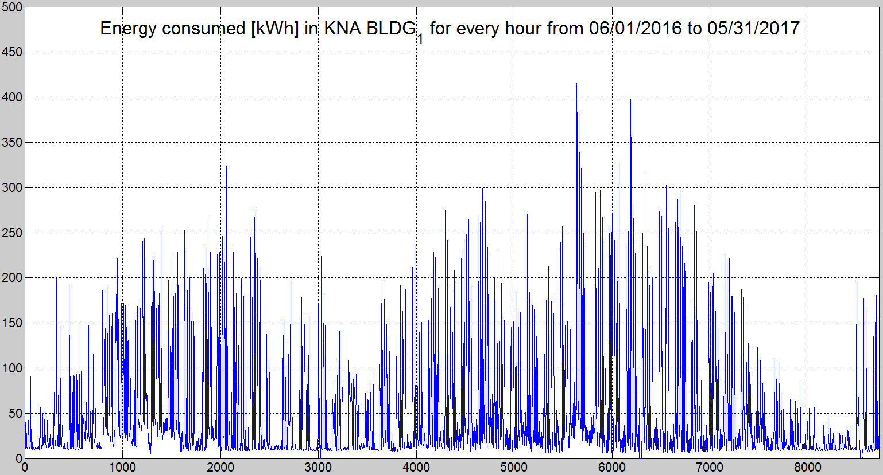

* Unit of X axis is hour.
* Unit of Y axis is kWh

1. The third column of MB_Power_xxxx

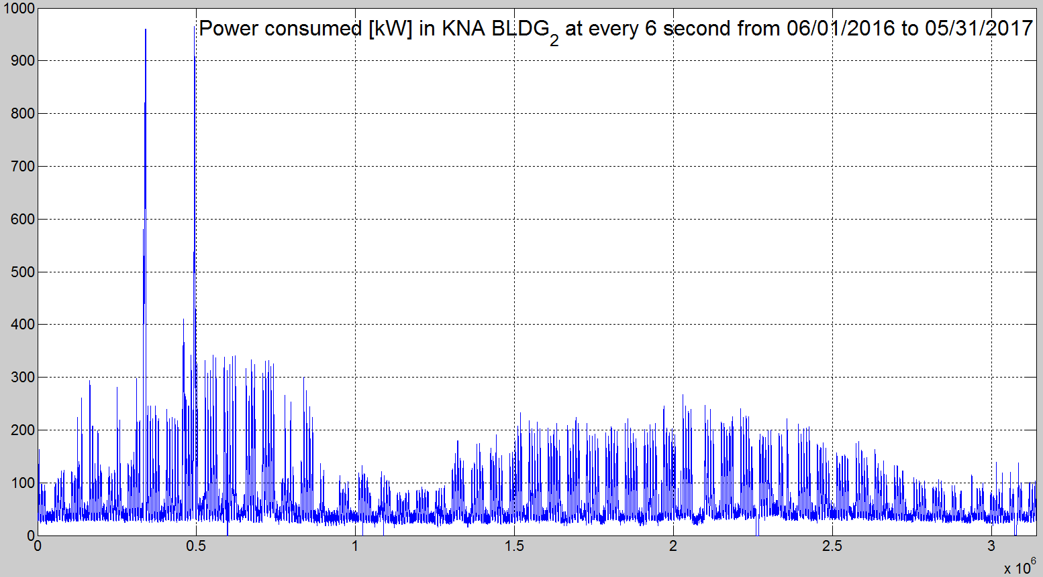

* Unit of X axis is X x 10sec
* Unit of Y axis is kW

1. The third column of MB_Eng_xxxx

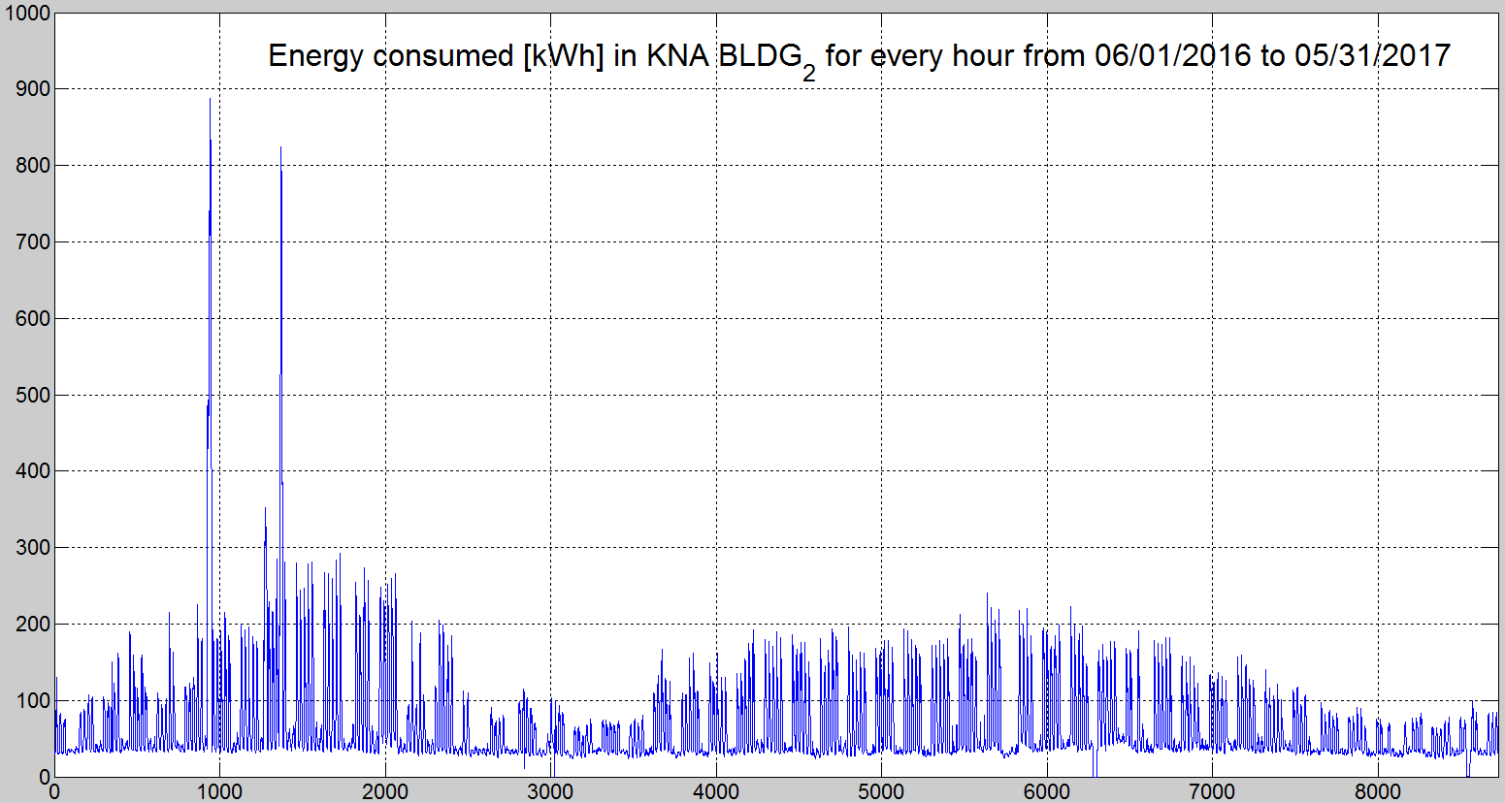

* Unit of X axis is hour.
* Unit of Y axis is kWh

1. The fourth column of MB_Power_xxxx

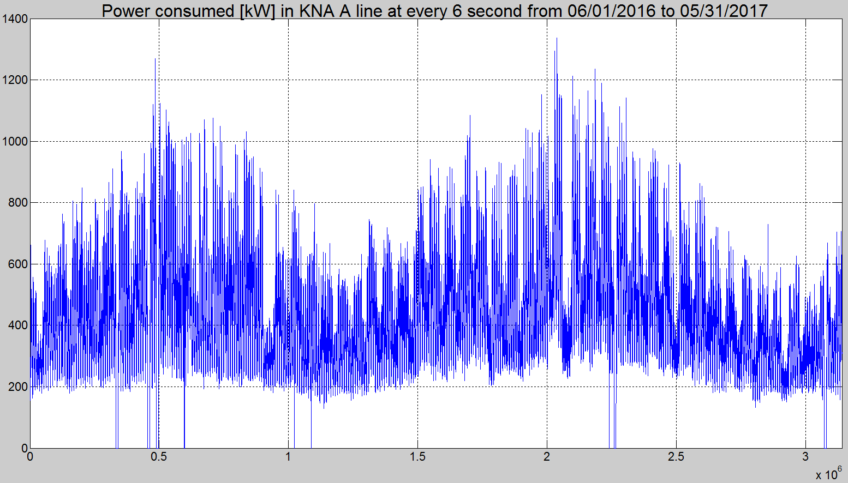

* Unit of X axis is X x 10sec
* Unit of Y axis is kW

1. The fourth column of MB_Eng_xxxx

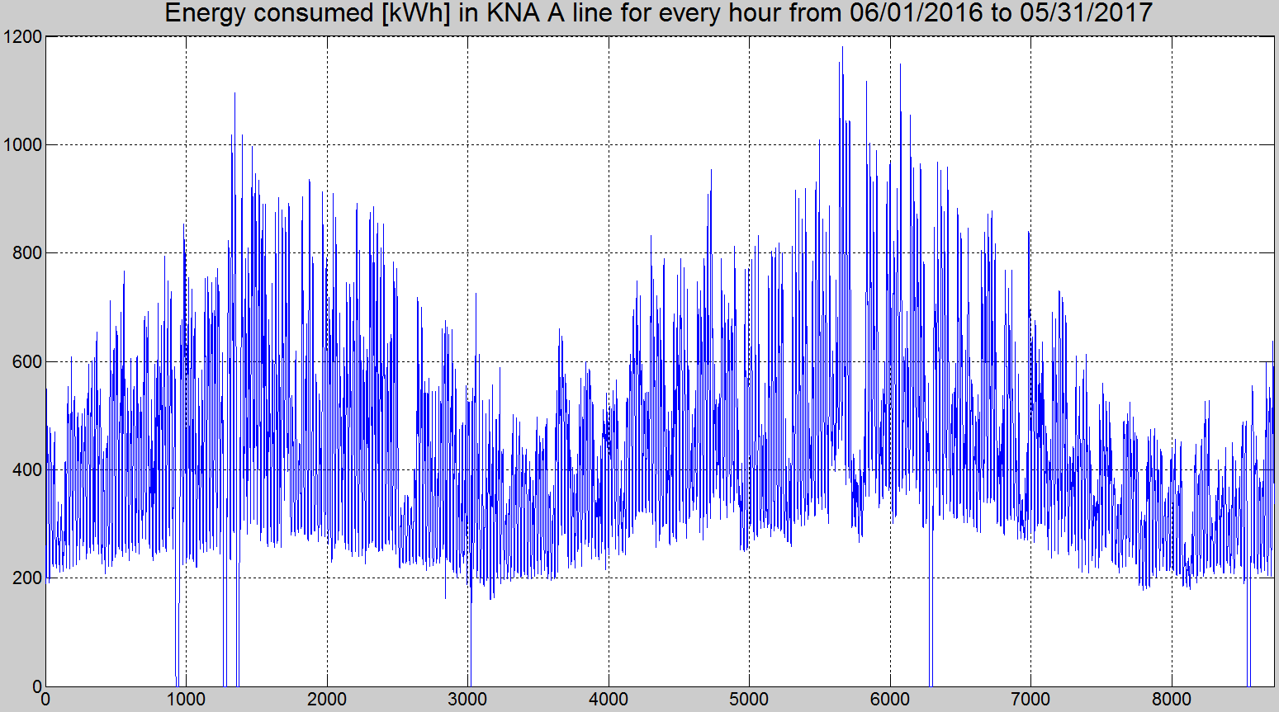

* Unit of X axis is hour.
* Unit of Y axis is kWh